Towards Sustainability, Livestock on the Move
CALL FOR POSTERS
The 8th Multi Stakeholder Partnership (MSP) meeting of the Global Agenda for Sustainable Livestock
Ulaanbaatar, Mongolia 11 to 15 June 2018

- Introduction
As well as the dedicated action network and open space sessions on Tuesday and Wednesday afternoons, the organizers welcome proposals by participants to exhibit posters. These can be stand-alone or can support a paper presented in the presentation space. The objective of the poster displays is to enhance the networking by informing the MSP participants on specific activities, best practices and tools to support sustainable livestock production.

The posters should relate to the theme ‘livestock on the move’ and to one of the 4 livestock sustainability priorities of the event (Global Food Security, Nutrition and Health, Livelihoods/Equity and Growth, Resources and Climate).

The theme ‘livestock on the move’ is inspired by the location of the meeting, in Mongolia, where mobile livestock keeping contributes so importantly to many livelihoods and to the economy of Mongolia. But the term goes well beyond a reference to livestock moving to search out seasonal feed resources. It also embraces the rapid dynamics that we are seeing in the global livestock sector; with shifts from smallholder production to more intensive, vertically integrated and geographically concentrated livestock systems. It also embraces the increase in trade, at a range of scales, not only in livestock products but also in live animals and in feed resources. This includes tele-coupled effects of livestock production and virtual trade in commodities such as nitrogen and water. It also embraces the emergence and movement of pathogenic agents associated with livestock production, such as avian influenza viruses and the genetic determinants of antimicrobial resistance. Movements of many kinds are a far more prominent features of today’s livestock agri-food systems and are likely to become even more so at these systems respond to the ever-growing demand for animal source foods.

- Format
Posters normally have an A0 size (841 mm x 1189 mm). Banners have often the same width (841 mm) but can be up to 2000 mm in length). These sizes are indicative. Posters will be posted to the wall with pins or tape, whereas the banners normally come with individual supports provided by the authors.

Posters and banners will be exhibited in a prominent place throughout the MSP meeting in the form of a market place. Poster and banner authors also will be provided a limited space to exhibit additional material. Poster and banner authors are invited to organize individual sessions around their posters during the MSP meeting. These sessions can take place during breakfast, coffee and lunch breaks.

Short video ‘posters’ or screenings may also be possible; please let us know and we can check possibilities.

- Timeline and process for poster applications
Interested presenters are requested to respect the following proposed timeline:

Date | Activities
15 April 2018 | Invitation to apply for a poster display issued by AST GASL.
05 May 2018 | Deadline for application to AST GASL (Anna.Grun@fao.org cc. Eduardo.ArceDiaz@fao.org).
15 May 2018 | Decision on selection of posters by AST GASL and MSP Task Force and guidance sent to applicants.
31 May 2018 | Deadline to submit all digital materials to AST GASL to be included in MSP documentation prior to the meeting
10 June 2018 | Poster/banner/video presenters displayed following guidelines from the organizers.

Application form for Posters
Remember: Bring your own poster to the event

Name, affiliation, address and e-mail of applicant
Associated GASL Action Network [if applicable]
Poster title
Summary of poster
[what concrete lesson, tool, approach, result or case will be shared]
The poster mainly contributes to the following SDGs  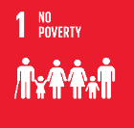  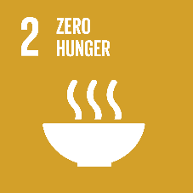  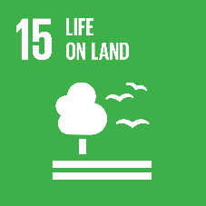  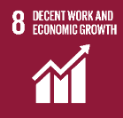  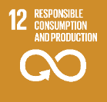 | [provide SDG numbers below]
The poster mainly contributes to global sustainable livestock priorities  [select one only] | [ ] Global Food Security  [ ] Nutrition and Health  [ ] Livelihoods/Equity and Growth  [ ] Resources and Climate
Expected format  [select one only] | [ ] Poster  [ ] Banner  [ ] Short video screening

