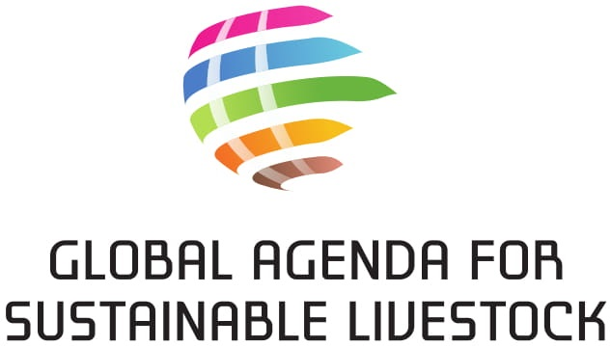

AGENDA CONSENSUS

- Recognizing that the UN Agenda 2030 for Sustainable Development, which builds on the Millennium Development Goals, provides a comprehensive framework for sustainable development, accepted by all countries and applicable to all;
- Convinced that livestock development has a key role to play for the attainment of the UN Agenda 2030;
- Conscious that each region faces specific challenges, and that there are different approaches, models and tools available in each region, in accordance with its circumstances and priorities, to achieve sustainable livestock in its economic, social and environmental dimensions;
- Taking an integrated approach to sustainable livestock that includes consideration of livelihoods, social impacts, public health and animal welfare, environmental impacts, land use and tenure, and biodiversity;
- Recognizing that the implementation of a Global Agenda for Sustainable Livestock depends on the active engagement of Governments, as well as civil society, the private sector, donors, academia and research institutions, NGOs, and Inter-governmental and Multi-lateral Organizations; and
- Accepting that the Global Agenda for Sustainable Livestock is open, consensual, inclusive, based on knowledge and mutual respect, and built on voluntary stakeholder engagement, including through its Focus Area groups and Knowledge Networks.

The signatories to this consensus agree to:
- Participate and engage actively in the Global Agenda for Sustainable Livestock as a dynamic and inclusive platform for evidence-based policy dialogue, knowledge exchange, and joint action at global, regional and national levels, supporting the achievement of the UN Agenda 2030 for Sustainable Development.
- Contribute to the capacity of the Global Agenda for Sustainable Livestock to build an improved understanding of livestock sustainability issues through existing evidence and/or generation of new knowledge, and to produce a diverse box of useful tools for practice and policy change.
- Commit with the other stakeholders of the Global Agenda for Sustainable Livestock to contribute to achieving local practice and policy change, focusing on continuous, context-specific improvement and innovation, and promoting livestock sector investments and project development.

Organization/agency: Click or tap here to enter text.
Legal representation
Mrs. ☐ Mr. ☐
First name: Click or tap here to enter text.
Signature:
Position: Click or tap here to enter text.
Last name: Click or tap here to enter text.
Date: Click or tap to enter a date.

Cluster
Please indicate which cluster your organization/agency belongs to (one tick).

☐ Public Sector
☐ Private Sector
☐ Academia/Research
☐ Donors
☐ NGOs
☐ Social Movements/Community based organizations
☐ Intergovernmental and multilateral organizations

Focal Point
The Focal Point will be in contact with the Global Agenda to receive meeting invitations, updates and information.
Mrs. ☐ Mr. ☐
First name: Click or tap here to enter text.
Nationality: Click or tap here to enter text.
Address: Click or tap here to enter text.
Position: Click or tap here to enter text.
Last name: Click or tap here to enter text.
Phone: Click or tap here to enter text.
Email: Click or tap here to enter text.

